AI Use Declaration Form
Course: Introduction to Artificial Intelligence
Lab Title: Lab 1 Part A & B — Uninformed and Informed Search Algorithms
Student Name: Desmond Boateng Barimah
Student ID: 44752028
GitHub Repository Link: https://github.com/dbbarimah/Barimah_Desmond_Lab1-
Date Submitted: 20th June, 2026

1. AI Use Summary
Question | Student Response
Did you use any AI tool for this lab? | Yes
Estimated percentage of the work influenced by AI | 15%
Did you attach evidence of AI use where applicable? | Yes

2. Details of AI Use
Complete the table below for each AI tool used. Add more rows where necessary.
Name of AI Tool Used | Purpose for Using the Tool | Prompt or Instruction Given to the Tool | Part(s) of the Work Influenced by the Tool | How I Verified, Edited, or Improved the AI Output
Claude | The tool was used to understand how the problem will be solved | “What is the AIMA style?” | Understanding the concepts
Claude | The tool was used to help in the correction of errors in code blocks. | “Is my implementation correct?” | Setting up of nodes based on the AIMA style
Claude | The tool was used to verify if the custom grid could be solved by the algorithm | “Is this a good grid to test the code?” | Custom grid formation

3. Attachment of AI Output Evidence
Where required, attach evidence of AI use. Tick all that apply. Add more rows where necessary.
Evidence Type | Attached? (Yes, No, N/A) | File Name
AI-generated draft
Prompt history
Screenshot of AI interaction | Yes | 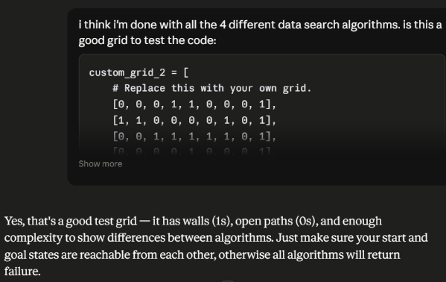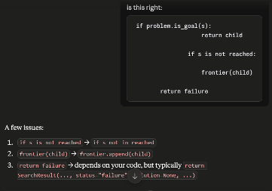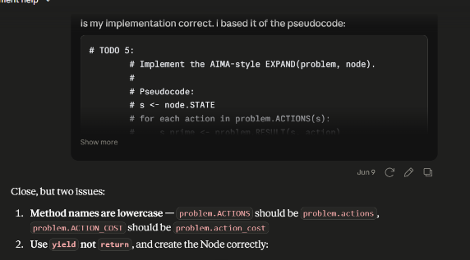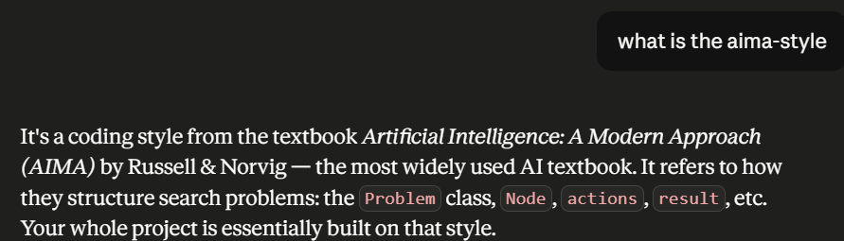
Exported AI conversation
AI-generated code snippet
Revised version showing student input

4. Student Declaration
I declare that:
Declaration Statement | Response (Yes/No)
The submitted work is my own work. | Yes
Any use of AI tools has been clearly declared in this form. | Yes
The prompts, instructions, and AI-generated outputs have been disclosed where applicable. | Yes
I reviewed, tested, edited, and improved any AI-generated content before submission. | Yes
My AI usage does not exceed 25% of the entire work. | Yes
I understand that undeclared or excessive AI use may be treated as academic misconduct. | Yes

Student Signature: D.B.B.
Date: 20th June, 2026

